Scheme of Studies, Syllabus
and
Model Question Paper
(For and from annual examination 2007)

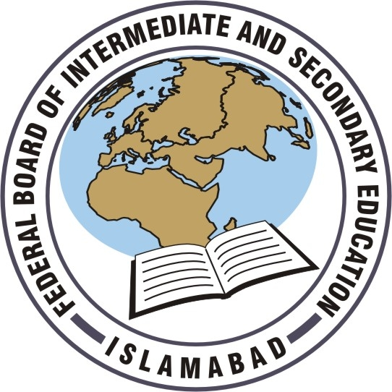

Higher Secondary School Certificate
Examination

CHEMISTRY
PART – 1

Research Wing
Federal Board of Intermediate and Secondary Education, Islamabad
Islamic Republic of Pakistan

TABLE OF CONTENTS

S. No. | Contents | Page No.
1. | Foreword | (i)
2. | Preface | (iii)
3. | Scheme of Studies | 1
4. | Aims and Objectives of Education Policy 1998 – 2010 | 3
5. | Aims and Objectives of Chemistry Syllabus | 7
6. | Contents and Scope of Chemistry Syllabus | 9
7. | Chemistry Practicals | 13
8. | Learning – Teaching Guidelines for Students and Teachers | 14
9. | Assessment and Evaluation | 19
10. | Definition of Cognitive Levels | 20
11. | Definition of Command Words | 21
12. | Recommended Reference Books | 23
13. | Model Question Paper | 24
14. | Mark Scheme | 37

FOREWORD

We are living in an extraordinary age characterized by stunning changes in social organization, economic well-being, modern philosophical and religious perspectives with a much advanced understanding of our universe. Education is vital to every aspect of human progress and development and therefore, for the first time in history educational development on a global scale tends to precede economic development.

Over the last five years the government of Pakistan has taken several initiatives to reform the teaching and learning in our schools and colleges. One of these reforms includes the designing and implementation of an examination system that ensures assessment of comprehension of concepts, analytical skills and critical approach of students.

In the present day teaching-learning process students resort to memorization and learn only what is needed to pass the examination; students rarely apply or integrate what they have learned in a realistic context. This hinders the ability of students to use concepts in new situations. Therefore, the examination system should take cognizance of the aims and objectives of the curriculum. In the concern for academic progress the basic aims of education should not be lost sight of. The Federal Ministry of Education has fixed priorities in the context of educational endeavours which aim at the improvement of teaching and examination system at all levels. An effective examination system can prove to be a vehicle for improvement in teaching-learning process and the improved quality of examination may in the long run result in improvement of the overall quality of education. If the examination system is reduced to simply testing how well students reproduce a given set of information, rote learning becomes the dominant culture, unimaginative teaching methods become the norm and schooling becomes a chore.
(i)
The present government has given a good deal of attention to reforming the secondary and higher secondary school curricula to raise the education standard. We need to improve the achievement of students through better instructional materials, curricula, more intensive teaching and better examination strategies and so on. Reaching these goals would depend on the extent to which teachers, principals and administrators have ready and continuing access to professional development in all areas of education.

The Federal Board of Intermediate and Secondary Education, in compliance with the policy perceived by the Ministry of Education, has undertaken the arduous task of enhancing the quality of its examinations. It has employed all possible resources in the pursuit of this national cause and has set another example of its commitment to excellence. I hope this will go a long way in improving the quality of education in Pakistan.

SAJID HASSAN
Secretary
Ministry of Education
(ii)

PREFACE

Education as a system largely relies on the curriculum and evaluation of the students’ knowledge through examination. Assessment and evaluation help enhance the student’s accomplishments and improve the teacher’s abilities and communication skills. A wide range of cleverly designed assessment and evaluation techniques in the education system can help the teachers closely follow student progress and facilitate future acquisition of knowledge.

The National Education Policy (1998-2010) of Pakistan outlines the evaluation strategy as one of its prime objectives at the Secondary and Higher Secondary level education by introducing a system of evaluation which emphasizes comprehension of concepts and discourages learning by rote. Over the past five years, assessment and improvement of students’ performance has been the focus of much discussion and efforts within the academic institutions and at the government level to adopt a novel and interesting approach to assessing students’ abilities and learning potential.

In line with the stated objective of the National Education Policy, the Ministry of Education launched appropriate and effective strategies for so regulating the examination system as to help the students comprehend and grasp ideas and hone their intellectual capabilities. The Federal Board while playing a leading role in restructuring the examination system under the directions of the Ministry of Education, undertook the responsibility for designing model question papers during 2002-2003 based on the revised National Curriculum. These model papers, divided into 3 sections, were distributed among the institutions. This was the first step to bring about changes in the assessment and evaluation system. This effort of the Federal Board was widely acclaimed in the educational circles.

Realizing and responding to the growing competition and changing trends in the field of education, the Federal Board has embarked on a process of bringing evolutionary changes in the conventional examination system. In the process it has taken a significant initiative and developed interaction and cooperation with Edexcel International, UK to bring about desirable improvements in the teaching methods and the examination system. As a part of cooperation experts from Edexcel International visited the Federal Board to analyze the content and quality of SSC and HSSC question papers and held useful discussions with the paper-setters. Building on the review of the suggestions and recommendations of Edexcel experts, the Federal Board has put in considerable time and effort to devise and implement an appraisal system that should draw forth, stimulate and nurture the creative potential of the students. In this connection, the Board held panel meetings with experienced teachers of public and private institutions and designed model question papers for the SSC composite examination 2007 and circulated them among all concerned.
(iii)

After the preparation of SSC model question papers as per Government directive, FBISE has prepared model question papers for HSSC Part – I examination to be held in 2007. In this context, experienced and competent teachers of ‘A’ level and HSSC level from private and public sectors were brought together to interact and blend the merits of both examination systems as well as prepare model papers to improve the quality of assessment and evaluation. The questions included in the model papers aim at testing the comprehension potential and capacity of the students based on knowledge, understanding and application. The Board aims at fostering an ordered intellect and encouraging the students to develop a conceptual approach to the subject studied so that they do not get stumped if they have to answer a question that is not straight from their text book.

This booklet contains examination syllabi and their scope, model question papers and their marking scheme, aims and objectives of each subject and instructional objectives for the teachers and students. Practical activities have also been included to inculcate a spirit of team-work and cohesion and to lend a fresh approach to studies. Previously, only course contents, extracted from the National Curriculum, were selected for the syllabus booklets. Now, greater part of the material from the National Curriculum has been included in this booklet which concerns both the teachers and the taught. Moreover, definitions of the command words have also been included which should help the teachers to frame questions in a manner that impels the students to equip themselves with the ability to clearly understand and learn concepts in order to solve the question paper. It presents the examination syllabus in detail and helps in introducing a wide range of teaching strategies from classroom techniques to the Board examination. Considerable stress has been laid on developing a principled approach to teaching that is neither dogmatic nor inflexible. Accordingly, this can serve as the teacher’s resource book. With emphasis on the development of comprehension, it has been shown how the evaluation procedure determines the extent of students’ learning or the extent to which instructional goals have been attained.
(iv)

This work is expected to become an essential reference tool for practising teachers, student – teachers, school and college administrators, and parents. It is, therefore, hoped that the information and guidelines provided in this booklet will lead to optimizing the learning pace of the students and the devotion and commitment of the teachers in the classroom.

We assure the readers of our unwavering readiness to accept both objective and meaningful criticism and constructive suggestions.

MUHAMMAD S SHAMSHAD
Commodore (Retd)
Chairman FBISE

(v)

